Group #36

JAM Electronics inc. (JE)

C.E.O Mathieu Sylvestre #260333709

C.R&D Juan Morency Trudel #260481762

Title: Lab 1 report g36_num1s

Description: This circuit counts the number of “1”s in a 4-bit input array and outputs the count in binary form. For example, if the input is 1101, the number of “1”s is 3 hence the output is 011.

Input: X (4 std_logic_vector)

Output: num1s (3 std_logic_vector)

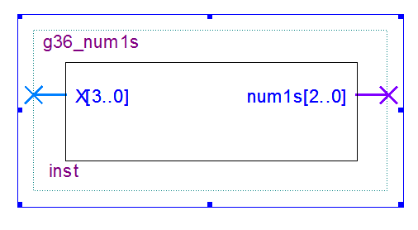

Gate level schematic:

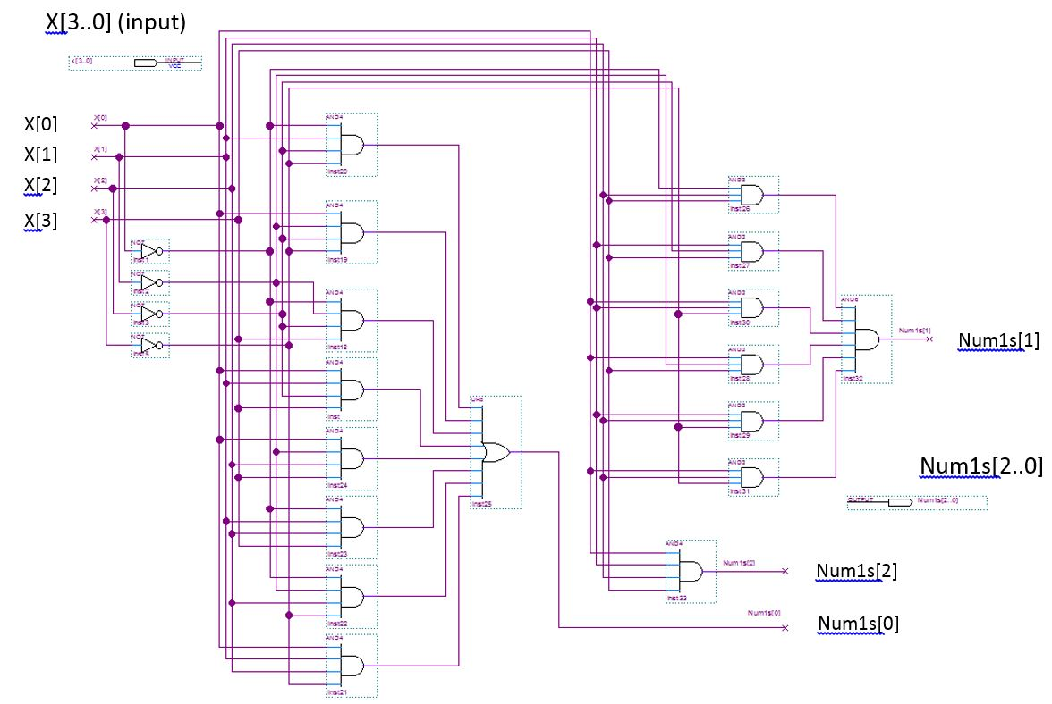

Testing:   
  
In order to test the function, we created TestBench that changes the values of X each 10 ns. With a “for” loop changed the value of X to all its 16 possible values.